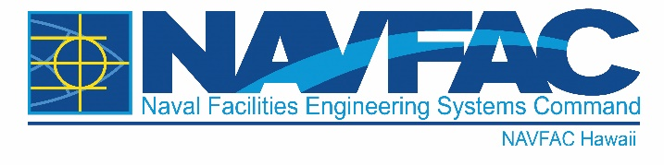

NEWS RELEASE
PUBLIC AFFAIRS OFFICE

FOR IMMEDIATE RELEASE: September 8, 2023 Release No. 23-03

Contact: Corwin Colbert, Public Affairs Officer Commanding Officer
Email: corwin.m.colbert.civ@us.navy.mil Naval Facilities Engineering Systems
Author: NAVFAC Headquarters Command, Hawaii
Ofc: 808-471-7300 400 Marshall Road
Cel: 808-457-7497 JBPHH HI 96860-3139
Fax: 808-474-5479
NAVFAC Hawaii Awards $85 Million contract modification for architect-engineer services

JOINT BASE PEARL HARBOR-HICKAM, Hawaii – Naval Facilities Engineering Systems Command (NAVFAC) Hawaii awarded $85,000,000 in capacity for a firm-fixed price, indefinite-delivery/indefinite-quantity modification to previously awarded contract to Jacobs/B&V, JV (Federal Services) Sept. 8.
This contract is for architect-engineer services and work will be performed at various locations within the NAVFAC Hawaii area of responsibility, including Hawaii; and other South Pacific Islands with an expected completion date of June 2025.
Work includes but is not limited to:
- utility projects, the execution and delivery of military construction project documentation
- functional analysis and concept development workshops, design charrettes
- design-build request for proposal solicitation documents
- design-bid-build design contract documents; cost estimates
- technical surveys and reports including concept studies, site engineering investigations and surveys
- collateral equipment buy packages
- comprehensive interior design, which includes structural interior design, furniture, fixtures and equipment packages
- post construction award services
For more information about NAVFAC Hawaii and/or Naval Facilities Engineering Systems Command visit:
www.navfac.navy.mil .
Naval Facilities Engineering Systems Command: The Facilities and Expeditionary Combat Systems Command
NAVFAC is the Naval Shore Facilities and Expeditionary Systems Command that plans, builds, and maintains sustainable facilities, delivers environmental, utilities and other base services, and acquires and manages expeditionary combat force systems and equipment. We are a global organization with a workforce of over 22,900, Government civilians, foreign national employees, contractors and military (active and reserve) with an annual volume of business in excess of $15 billion.
For more information about NAVFAC Hawaii, visit us at www.navfac.navy.mil/navfac_worldwide/pacific/fecs/hawaii.html, www.facebook.com/navfachawaii/, www.twitter.com/navfac, and/or www.flickr.com/photos/navfac.
Naval Facilities Engineering Systems Command: www.navfac.navy.mil

